

**LAB 2**

**SUBMITTED BY- SUBMITTED TO-**

**PRASHANT KUMAR SINGH SOURABH JAIN SIR**

**BRANCH - COMPUTER SCIENCE**

**ROLL NUMBER - 12111019**

**MOBILE – 6394287313**

* 1. **- Print position of smallest number in array.**

#include<stdio.h>

int main()

{

int list[50],n,i,smallest,position;

printf("how many elements do you want to add in list?\n");

scanf("%d",&n);

for(int i = 0; i<n; i++)

{

scanf("%d", &list[i]);

}

smallest = list[0];

position = 0;

for(int i = 0; i < n; i++)

{

if (list[i]<smallest)

{

smallest = list[i];

position = i+1;

}

}

printf("smallest number is - %d and position is - %d",smallest,position);

return 0;

}

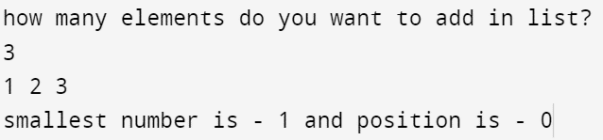

* 1. **Insert an element**

#include <stdio.h>

int main()

{

int n, i, a, b;

int arr[100], arr2[100];

printf("How many elements you want to enter?: ");

scanf("%d", &n);

for (i = 0; i<n; i++)

{

printf("Element %d: ", i);

scanf("%d", &arr[i]);

}

printf("At what position, do you want to add new value? ");

scanf("%d", &a);

printf("Insert the value to add: ");

scanf("%d", &b);

for (i=0; i<n+1; i++)

{

if (i<a)

{

arr2[i] = arr[i];

}

if (i==a)

{

arr2[i] = b;

}

if (i>a)

{

arr2[i] = arr[i-1];

}

}

printf("New array is: ");

for (i=0; i<n+1; i++)

{

printf("%d ", arr2[i]);

}

return 0;

}

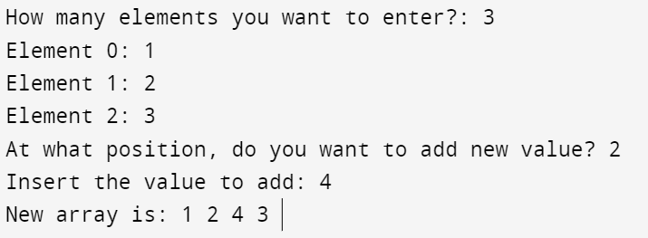

* 1. **Delete a given element.**

#include <stdio.h>

int main()

{

int n, i, a, b, arr[50], arr2[50];

printf("How many elements you want to enter?: ");

scanf("%d", &n);

for (i = 0; i<n; i++)

{

printf("Element %d: ", i);

scanf("%d", &arr[i]);

}

for (i = 0; i<n; i++)

{

printf("%d Element is - %d\n",i,arr[i]);

}

printf("Which element (value) do you want to delete? ");

scanf("%d", &a);

for (i = 0; i<n; i++)

{

if (arr[i]==a)

{

b = i;

break;

}

}

for (i=0; i<n; i++)

{

if (i<b)

{

arr2[i] = arr[i];

}

if (i>b)

{

arr2[i-1] = arr[i];

}

}

printf("New array is: ");

for (i=0; i<n-1; i++)

{

printf("%d ", arr2[i]);

}

return 0;

}

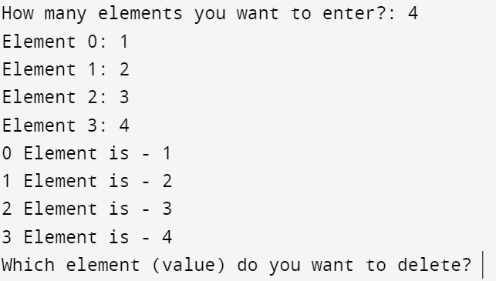

* 1. **Find a given element.**

#include <stdio.h>

int main()

{

int n, i, a, b,arr[50],arr2[50];

printf("How many elements you want to enter?: ");

scanf("%d", &n);

for (i = 0; i<n; i++)

{

printf("Element %d: ", i);

scanf("%d", &arr[i]);

}

printf("Enter the element: ");

scanf("%d", &a);

for (i = 0; i<n; i++)

{

if (arr[i]==a)

{

b = i;

break;

}

}

printf("The element is present at %d position.\n", b);

return 0;

}

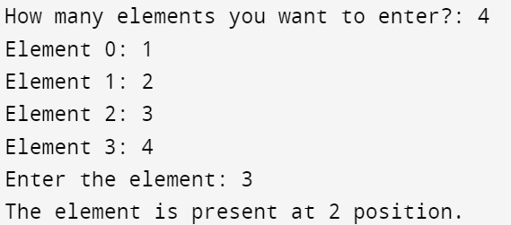

1. **Write a program to calculate x^y (Using Recursion).**

#include <stdio.h>

int powr(int a, int b);

int main()

{

int a,b;

printf("Enter a: ");

scanf("%d", &a);

printf("Enter b: ");

scanf("%d", &b);

printf("%d^%d is equal to %d", a, b, powr(a, b));

return 0;

}

int powr(int a, int b)

{

if (b == 0)

{

return 1;

}

else

{

return a * powr(a, b - 1);

}

}

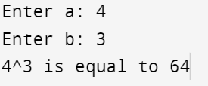

1. **Write a program to solve TOH (Tower of Hanoi).**

#include <stdio.h>

void towers(int, char, char, char);

int main()

{

int num;

printf("Enter the number of disks : ");

scanf("%d", &num);

printf("The sequence of moves involved in the Tower of Hanoi are :\n");

towers(num, 'A', 'C', 'B');

return 0;

}

void towers(int num, char frompeg, char topeg, char auxpeg)

{

if (num == 1)

{

printf("\n Move disk 1 from peg %c to peg %c", frompeg, topeg);

return;

}

towers(num - 1, frompeg, auxpeg, topeg);

printf("\n Move disk %d from peg %c to peg %c", num, frompeg, topeg);

towers(num - 1, auxpeg, topeg, frompeg);

}

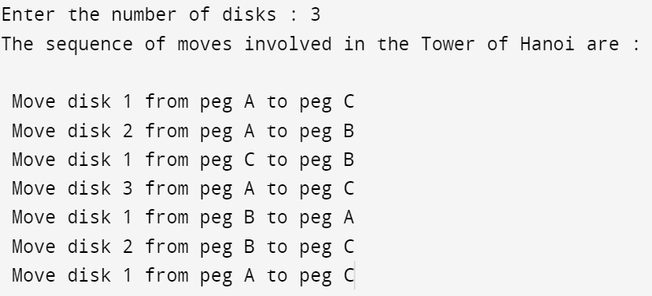

1. **Write a program for sorting an array using Bubble sorting.**

#include <stdio.h>

int main()

{

int n, i, j, temp,arr[100];

printf("Enter the elements in array: ");

scanf("%d", &n);

int ;

printf("Enter the elements.\n");

for (i = 0; i < n; i++)

{

printf("Enter element %d: ", i);

scanf("%d", &arr[i]);

}

for (i = 0; i < n; i++)

{

for (j = 0; j < n - 1; j++)

{

if (arr[j] > arr[j + 1])

{

temp = arr[j];

arr[j] = arr[j + 1];

arr[j + 1] = temp;

}

}

}

printf("Sorted array Using Bubble Sorting: ");

for (i = 0; i < n; i++)

{

printf("%d ", arr[i]);

}

return 0;

}

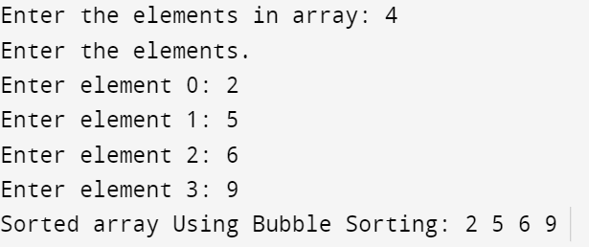

1. **Write a program for sorting an array using Insertion sorting.**

#include <stdio.h>

int main()

{

int n, i, j, key,arr[50];

printf("Enter the elements in array: ");

scanf("%d", &n);

printf("Enter the elements.\n");

for (i = 0; i < n; i++)

{

printf("Enter element %d: ", i);

scanf("%d", &arr[i]);

}

for (i = 0; i < n - 1; i++)

{

key = arr[i + 1];

j = i;

while (j >= 0 && arr[j] > key)

{

arr[j + 1] = arr[j];

j = j - 1;

}

arr[j + 1] = key;

}

printf("Sorted array Using Inserted Sorting: ");

for (i = 0; i < n; i++)

{

printf("%d ", arr[i]);

}

return 0;

}

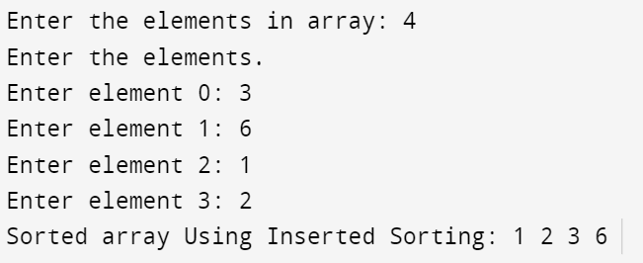

1. **Write a program for sorting an array using Selection sorting.**

#include <stdio.h>

int main()

{

int n, i, j, min, temp, k;

printf("Enter the elements in array: ");

scanf("%d", &n);

int arr[n];

printf("Enter the elements.\n");

for (i = 0; i < n; i++)

{

printf("Enter element %d: ", i);

scanf("%d", &arr[i]);

}

for (i = 0; i < n; i++)

{

min = arr[i];

for (j = i + 1; j < n; j++)

{

if (arr[j] < min)

{

min = arr[j];

}

}

for (k = i; k < n; k++)

{

if (arr[k] == min)

{

temp = arr[i];

arr[i] = arr[k];

arr[k] = temp;

}

}

}

printf("Sorted array Using Selection Sorting: ");

for (i = 0; i < n; i++)

{

printf("%d ", arr[i]);

}

return 0;

}

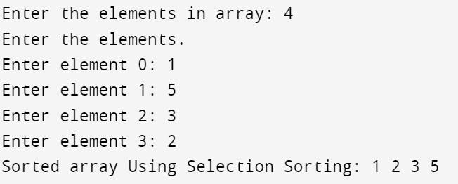

1. **WAP to find the sum of each row and column of a matrix separately.**

#include <stdio.h>

int main()

{

int r, c, i, j, matrix[50][50], arr1[50], arr2[50];

printf("Enter the number of Rows: ");

scanf("%d", &r);

printf("Enter the number of Columns: ");

scanf("%d", &c);

printf("Enter the elements-\n");

for (i = 0; i < r; i++)

{

for (j = 0; j < c; j++)

{

printf(" %d: ", j + 1);

scanf("%d", &matrix[i][j]);

}

}

for (i = 0; i < r; i++)

{

arr1[i] = 0;

for (j = 0; j < c; j++)

{

arr1[i] = arr1[i] + matrix[i][j];

}

printf("Sum of row %d= %d\n", i + 1, arr1[i]);

}

for (i = 0; i < c; i++)

{

arr2[i] = 0;

for (j = 0; j < r; j++)

{

arr2[i] = arr2[i] + matrix[j][i];

}

printf("Sum of column %d= %d\n", i + 1, arr2[i]);

}

return 0;

}

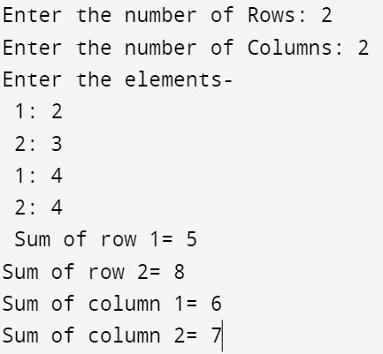

1. **Write a program to calculate Mean and Standard Deviation of elements of an array.**

#include <stdio.h>

#include <math.h>

int main()

{

int n, i, sum1 = 0, sum2 = 0, arr[50], arr2[50];

float mean, var, standard_deviation;

printf("Enter the number of elements in array: ");

scanf("%d", &n);

for (i = 0; i < n; i++)

{

printf("Element %d: ", i);

scanf("%d", &arr[i]);

}

for (i = 0; i < n; i++)

{

sum1 = sum1 + arr[i];

}

mean = (sum1 * 1.0) / n;

printf("The mean is %.3f\n", mean);

for (i = 0; i < n; i++)

{

arr2[i] = pow(arr[i] - mean, 2);

}

for (i = 0; i < n; i++)

{

sum2 = sum2 + arr2[i];

}

var = sum2 * 1.0 / n;

standard_deviation = pow(var, 0.5);

printf("Standard Deviation is %.3f", standard_deviation);

return 0;

}

